**9. BEAMLINE CONTROLS**

**9.1 General Hardware Plan**

**9.1.1 General Hardware**

NYX uses Galil DMC-4080 advance motion controllers to control NYX beamline photon delivery and experimental station. It takes care all the motion controls, most I/Os, temperature monitoring and analog input. The Galil motor amplifiers are built in with the controller. We embeded the Galil controllers in a costum built control cabinet located near each of the major beamline components and end station. The advantage of such configuration is that it eliminates long motor and encoder cable to the motor amplifier and controllers. The main control PC communicate to the Galil controller through Ethernet.

**9.1.2 Device and Interface list**

|  |  |  |  |  |  |
| --- | --- | --- | --- | --- | --- |
| Device Name | Function | Specification | controlled by | Interface | Protocol Name |
| GUI PC | User interface to control experiment | Intel Processor base PC | - | - | - |
| Galil  Motor  Controller | Control motors and encoders |  | GUI PC | eth | proprietary |
| Galil Pocket PLC | Analog Input  Timer and  Counter |  | GUI PC | eth | proprietary |
| Mean Well | Power Supply | 24V-48V |  | eth |  |
| Galil SCB  48316 | K thermal card for reading motor temperature sensor | Galil | Galil | eth | analog |
| Renishaw | Encoder |  | Galil |  | quadrature |
| MicroE Mercury2000-MV | Encoder |  | Galil |  | quadrature |
| Phtron | Vacumm Motors |  | Galil |  |  |
| PM170 | McLennan servo  Driver |  | Galil | - | - |
| M543E | Mclennan Servo  Motor for Phi |  | Galil |  |  |
| Stogra SM56.2.18.J3 | Steppers for Mirror |  | Galil |  |  |
| VEXTA PK266M-03A | NSLS2 Stage |  | Galil |  |  |
| Nanotec 2 phase | Stepper for 4 Jaw slits |  | Galil |  |  |
| NEMA 17-4018 | Stepper for Beam mask |  | Galil |  |  |
| HaydonKerk 57H4A 3.25 050 ENG 0716 | Steppers for Crystal logic diffractometer |  | Galil |  |  |
| Oriental Motor AR66MA-N10-3 | Stepper for Crystal logic table |  | Galil |  |  |
| Lin WO-211-18-02D | Steppers for camera and sample stage |  | Galil |  |  |
| FaulhaberAM15A0046 | Steppers for Crystal Logic Slits |  | Galil |  |  |
| McLennan 23HSX206 | Stepper for filter |  | Galil |  |  |
| LS | Limit switches for motion | - | Galil | 5v DIO | TRUE/FALSE |
| Physik Instrument P-841-30 | Stain gauge for Mono Benders |  | Galil | 0-10V |  |
| PI E-500  Modular Piezo controller | Control Piezo |  | Galil | 0-10V |  |
| Infinity Strain Meter | Mirror bending force reader |  | Galil | 0-10V |  |
| IOC | Hosts PVs, integrates connected devices | NSLS2 compliant | GUI PC | eth | CA |
| PLC | Read temperature, implement Interlock logic | Allen Bradley Compact Logix | IOC | eth | EtherIP |
| GB | DeltaTau Geobrick IMS 2 Motion controller | BNL compliant | IOC | eth | DeltaTau proprietary |

* + 1. **Major Components of ID-19 Control System**

9.1.3.1 End Station

* Diffractometer Crystal Logic
* Auto Mounter Crystal Logic
* Dual Mode detector ADSC
* Camera Server Axis
* BPM System BNL/Libera

9.1.3.2 Optics

* Monochrometer Oxford FMB
* Mirror Irelect

9.1.3.3 Insertion Device

* Undulator X25-NSLS

9.1.3.4 Control Computer

* Intel based PC

Central Control PC

Undulator

MONO

Mirror

Diffractometer

Slits, Tables,Filter Beam mask

Figure 1. Connection Schematics

* 1. **Software Plan**

BLU-ICE is a graphical Interface to the Distributed Control System (DCS) for crystallographic data collection at Synchrotron Beamline. It’s designed and developed by SSRL. Blu-Ice has been widely used in the crystallography beamlines worldwide. It’s a proven control software and has the reputation of elegant and user friendly. We have used Blu-Ice in NYX beamline X4 at NSLS for the past 5 years. Blu-Ice controls all the major components of X4 end station. Our experinwce with Blu-Ice can be sumerized as the following:

1. User friendly. It’s easy to use. The GUI is self explanatory. User can master beamline control and data collection in a very short time. Our user loves it.
2. Central control. All the beamline control and data collection under one GUI. not like many beamline software, user need to open so many windows for the different controls. It’s sometimes so confusing and annoring.
3. It controls or monitors the data collection locally and remotely. Bluice can be access by many users at the same time to monitor their experiment locally and remotely. Users are able to view all the process the experiments. But only one user is allowed to control the experiments.
4. It’s secure. The authentication sever takes care the user login security. Each user can have their own user name and password to access the software and collect their data securely.
5. It’s reliable. With our old control softwares, we needed to reboot the computers and restart the softwares once a while. We had very smooth operation since used Blu-Ice. We very rarely restart reboot and restart the software unless there are changes in the software.
6. It’s efficient. The experimental processes are standardized. User can just use data collection number tabs to setup multiple data collections and run them continuously.
7. Many experimental procedures and scripts are already developed. It includes many very useful features for the beamline control. We can just simply use them or modifiy them for our use. It saves us a lot of time to develop them.
8. Easy to expand and upgrade. The new hardware can be fairly easy added in the system. SSRL provides many useful template. We also have full access of the Blu-Ice repository so that we can upgrade to the newer version of the Blu-Ice whenever it’s available.
9. Excellent support from SSRL. The People in the control group of SSRL are extremely helpful. They are always abailable for us if we need help for all these years.

.

**9.2.2 Overview Blu-ice Control System**

1. **GUI**
2. **DCSS**
3. **DHS/EPICS Gateway**

Robot

Detector

Camera

Motors

BLUICE GUI

DCSS

EPICS Gateway (DHS)

DHS

Motors

Other devices

EPICS IOC

Figure 3. Blu-Ice Control Block diagram

**9.2.2.1 DCSS**

Distributed Control System Server is a centralized sever. It handles the communications between GUI and DHS. It has two basic functions.

1. **Message handler:**

It delivers messages from Blu-ice GUI to DHS to control the devices and broadcast messages from DHS to all the GUI

GUI <------> DCSS <--------> DHS <-------> Device

1. **Script Engine:**

It also a special Client called “self” for Both DCSS and Blu-Ice GUI. It can receive all the messages from DHS and access all the DHS. It can executes the user defined scripts which controls devices.

The DCSS is running in the Central Control PC.

**9.2.2.2 DHS**

Distributed Hardware Server is a program which directly talk to devices. It accept DCS message and control a piece of hardware directly. It report the status of the device to the DCS.

**9.2.2.3 Blu-ice DCS Framework**

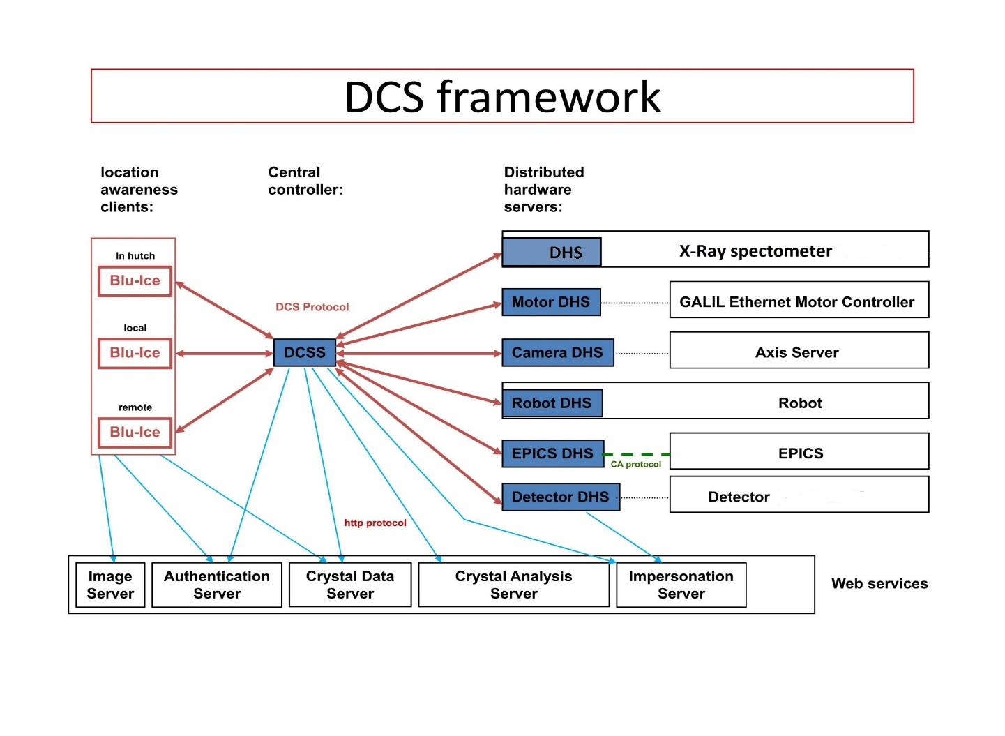Figure 5. DCS Framework [1]

**9.2.2.4 Features of the Framework**

* **Central Control**
* **Security**
  + **Authentication Server**
  + **Impersonation Servr**
* **Web-Ice[2] service**
  + **Crystal Information Server**
  + **Crystal Analyze Server**

**9.2.2.5 Bluice GUI**

**9.2.2.5.1 Hutch Tab**

The **Hutch Tab** allows the users to adjust various parameters for data collection.

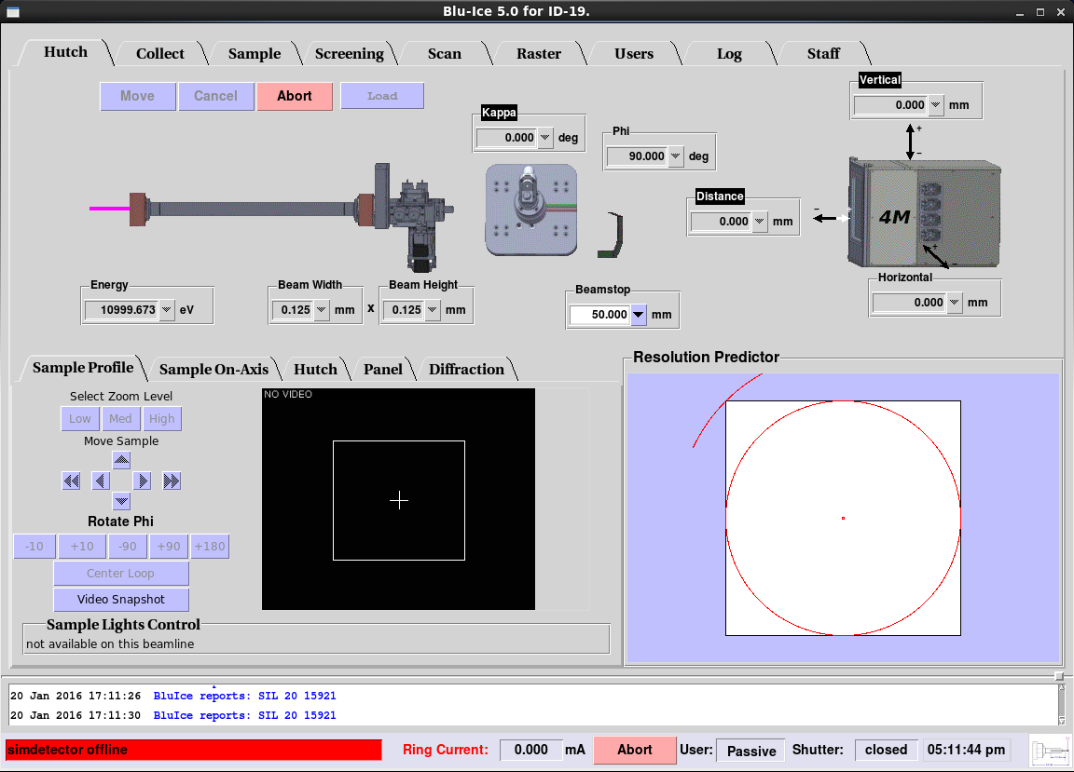

Figure 5. Hutch Tab

**9.2.2.5.2 Data Collection Tab**

The Collect Tab is used for collecting test images and complete monochromatic, SAD and MAD data sets. Multiple run windows can be set up by creating additional Run Tabs.

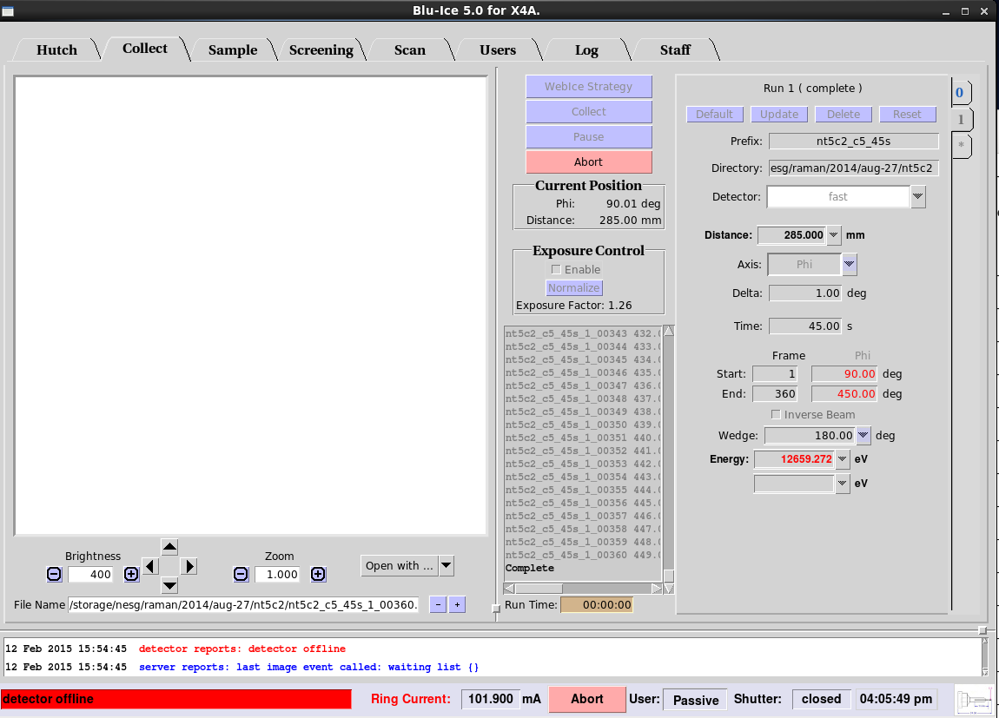

Figure 6. Data Collect Tab

**9.2.2.5.3 Sample Tab**

The **Sample Tab** allows the user to prepare the sample for data collection: The user can change the sample camera zoom and adjust the sample position, change the beam size , mount and dismount additional samples with the SAM robot, remove ice, and anneal the crystal.

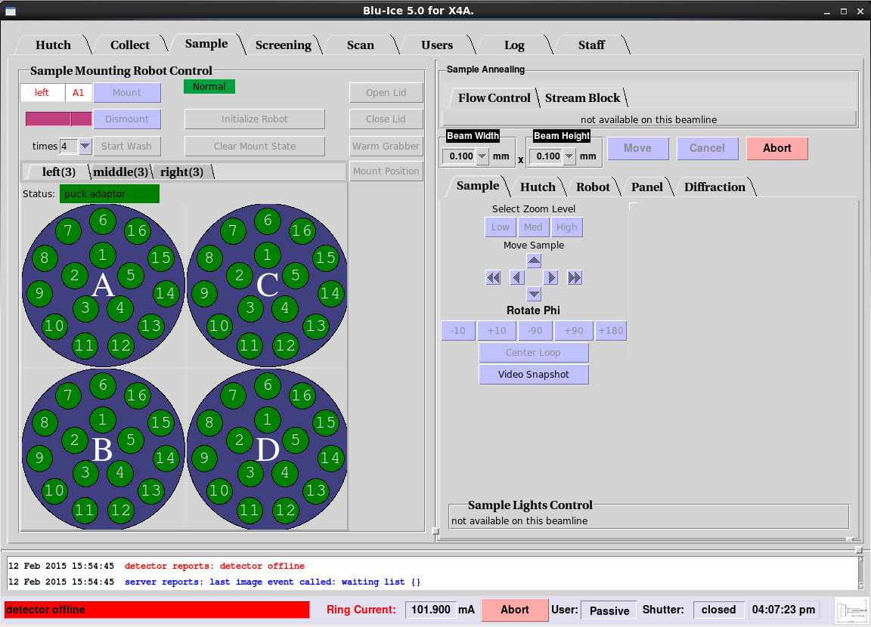

Figure 7. Sample Tab

**9.2.2.5.4 Screen Tab**

The Screening Tab provides an interface for automatically screening samples. With this interface, the user selects multiple samples of interest from an embedded spreadsheet and defines the actions to be performed on each sample. Once started, the interface can run with minimal supervision until all of the samples have been screened identically.

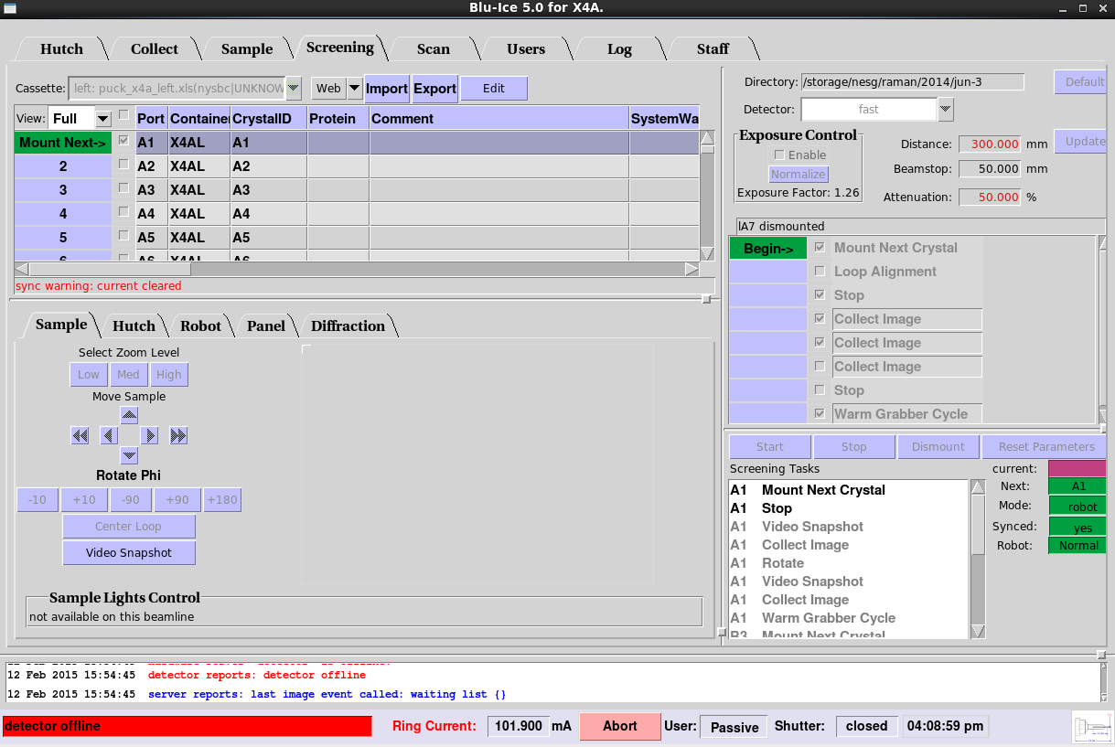

Figure 8. Screen Tab

**9.2.2.5.5 Scan Tab**

The **Scan Tab** is used for energy and excitation scans. The energy (MAD) scans are used to select the appropriate wavelengths for anomalous dispersion experiments ([optimized SAD and MAD)](http://smb.slac.stanford.edu/users_guide/datacollect/mad_collect.html). The excitation scan is useful to identify and verify the presence of anomalous scatterers in the sample

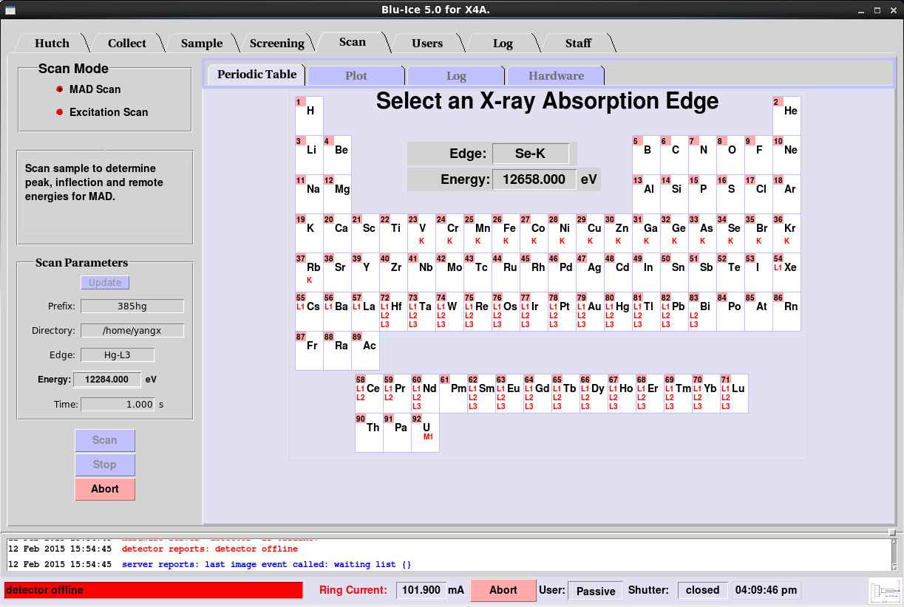

Figure 9: Scan Tab

**9.2.2.5.6 Raster Tab**

The **Raster tab** allows the user to search for and align crystals based on low level diffraction. This is carried out by defining a 3-dimensional raster, recording low level diffraction images, and then processing them with "Spotfinder" using a specialized input file tailored for weak low resolution spots and detector characteristics.

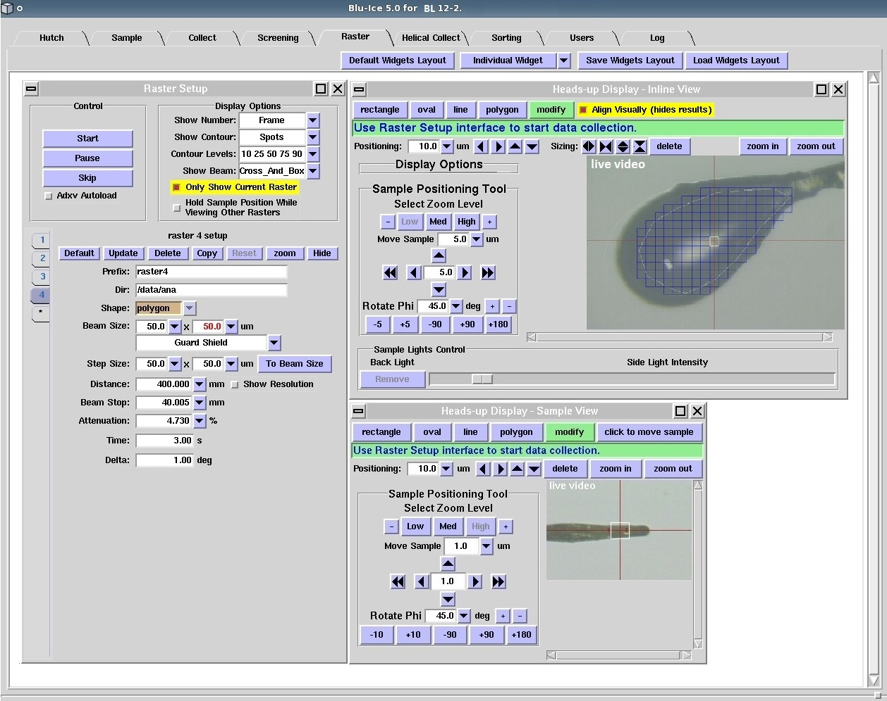

Figure 10. Raster Tab [1]

**9.2.2.5.7 Helical Collection Tab**

The **Helical Tab** allows collection of oscillation data while translating the crystal along the spindle axis: The software collects one oscillation image before moving the crystal to a new position and collecting a new image, with the new oscillation starting where the previous one ended.

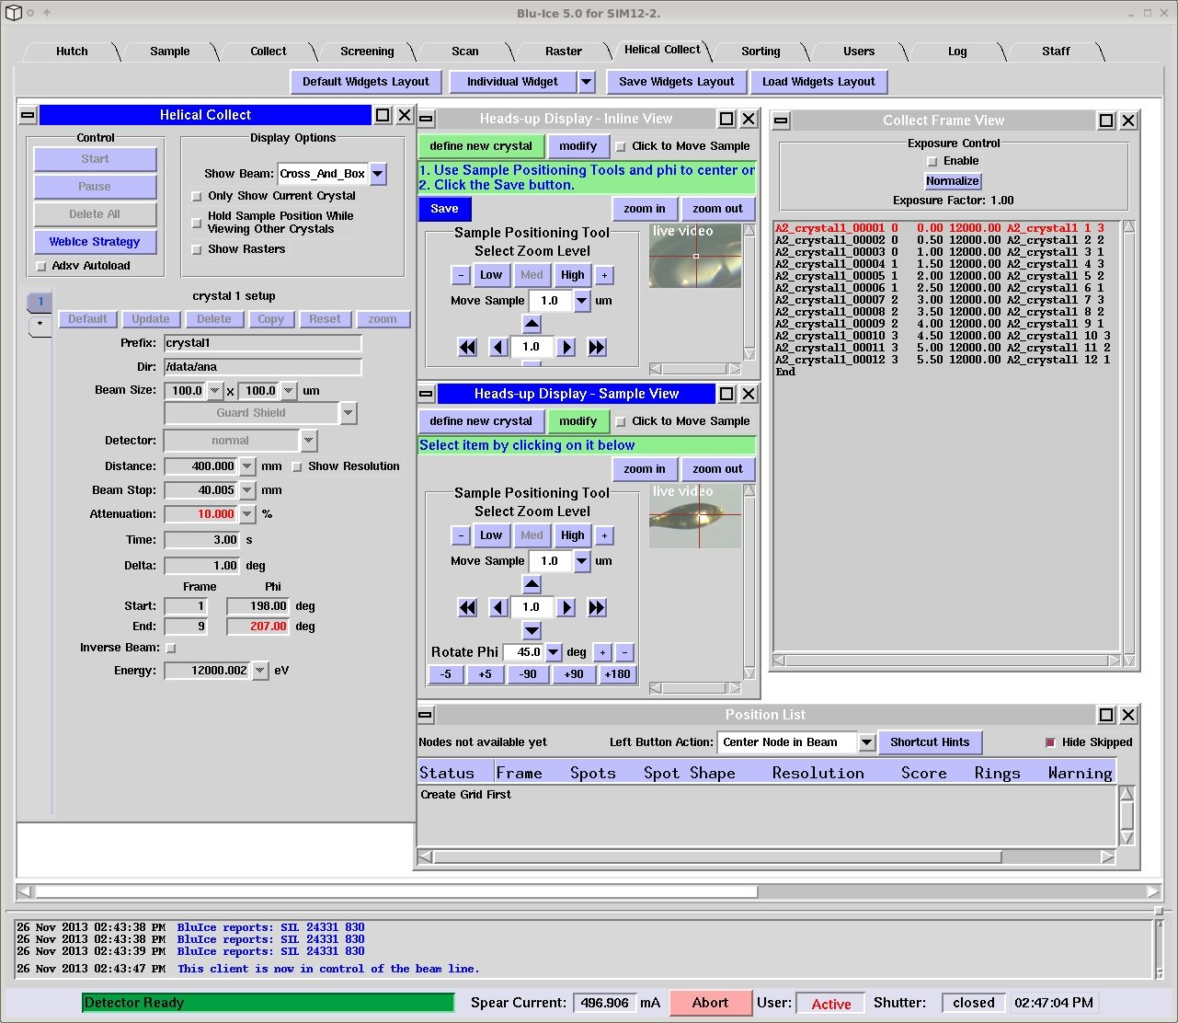

Figure 11. Helical Collection Tab [1]

**9.2.2.6 Summary on Blu-Ice**

1. Least risk (transition from X4 to NYX); Easy to manage for a small group with limited recourse.
2. Minimal development work required; Good support from SSRL.
3. Take advantages of using other software developed with BluIce like Web-Ice[2] and Autodrug[3].

**References**

[1] Figures courtesy of SSRL

[2]  A. González, P. Moorhead, S. E. McPhillips, J. Song, K. Sharp, J. R. Taylor, P. D. Adams, N. K. Sauter and S. M. Soltis "*Web-Ice*: integrated data collection and analysis for macromolecular crystallography." *J. Appl. Cryst.* 41, 176-184 (2008).

[3] Yingssu Tsai, Scott E. McPhillips, Ana Gonzalez, Timothy M. McPhillips, ´ Daniel Zinn, Aina E. Cohen, Michael D. Feese, David Bushnell, Theresa Tiefenbrunn, C. David Stout, Bertram Ludaescher, Britt Hedman, Keith O. Hodgson and S. Michael Soltis. AutoDrug: fully automated macromolecular crystallography workflows for fragment-based drug discovery Acta Cryst. (2013). D69, 796–803

**9.3 DESCRIPTION & DISTRIBUTION OF LOCAL CONTROL CABINETS**

There are four local control cabinets designated for the NYX beamline. There is an additional local control cabinet for the LAX line.

Each local control cabinet contains motor drivers and ancillary components for up to 12 motions. Each cabinet will be mounted near the motors it drives, so motor and encoder cables will be kept short, as well as any other cables such as thermocouple. Each cabinet has its own internal DC power supplies, so the cabinet will need only a single AC cord for power, and an Ethernet line for communications.

**Locations:**

For the NYX line, there are four designated cabinets: LCC2, LCC3, LCC4, and LCC5.

LCC2 will be mounted on the upstream C-hutch wall and will control beam position monitor 1, an aperture, and filters.

LCC3 will be mounted in the C-hutch on the monochromator plinth and control the monochromator motions as well as beam position monitor 2.

LCC 4 will be mounted in the C-hutch on the mirror plinth, and will control the motions of the mirror as well as the 4-jaw slits and beam position monitor 3.

LCC 5 will be mounted in the D-hutch on the pathway stand, and will control the four motions of the pathway.

The control cabinets are 600mm x 800mm x 300mm, and are manufactured by Hoffman. They are sealed with high-density foam gasketing on all removable panels and the door, and use Roxtec glands for cable entry. There is a fan and a passive vent.

The contents of each cabinet is arranged around a large aluminum patch panel, which serves to mount the Galil motor drivers, as well as all the connectors needed to interface the Galils with the motors. In addition, each cabinet has two DIN rails to mount DIN components.

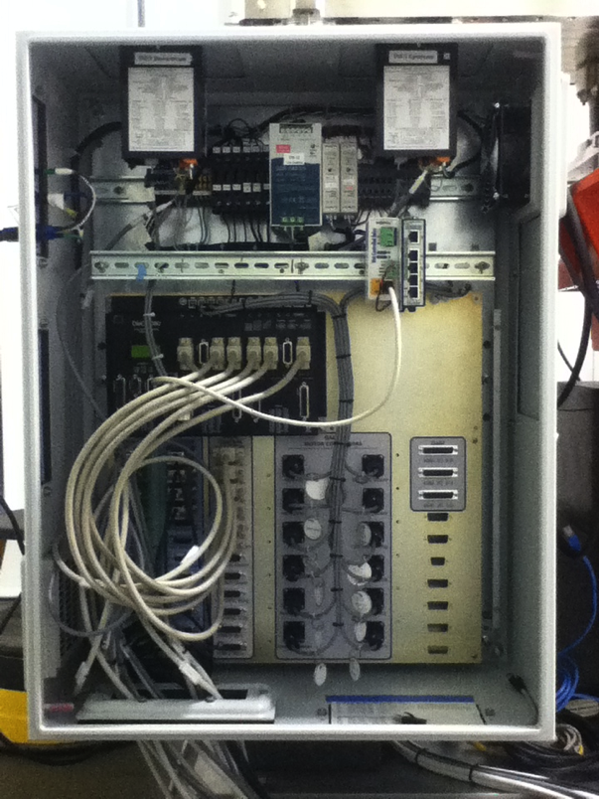

The large aluminum panel on which the Galil drivers are mounted acts as an additional heat sink. Then, forced air cooling removes the heat from the cabinet. There is a passive vent on the lower right of the cabinet, and a five inch fan blowing air out on the upper right of the cabinet, drawing air across the Galils.

The electronic components common to every LCC are:

Galil DCM-4080 – 8-motion controller/driver

Galil DCM-4040 – 8-motion controller/driver

Meanwell SDR-240-24 - 10amp 24vdc power supply – for Galil and motor power

(2) Meanwell MDR-20-24 - 1 amp 24vdc power supplies – for Netswitch and Web-relay

Stride Netswitch SE-SW5U-WT - to distribute ethernet within the cabinet

Xytronix WebRelay X-WR-1R12-1I5-I to enable a remote shutdown function

Also, there are a few location-specific components, such as the readouts for the strain gauges on the mirror (LCC4), and the crystal heater with its power supply for the monochromator (LCC3).

Components specific to the monochromator cabinet, LCC3, are:

Jumo Ctron crystal heater and power supply

Components specific to the mirror cabinet, LCC4, are:

(2) Rockport INFS strain gauge readouts for the mirror bender

There is a power distribution harness for AC and DC which uses DIN terminal blocks and fuses. The cabinet has a main fuse, and each AC powered device within the cabinet has its own fuse, this includes the DC power supplies as well as the fan. In addition, each DC powered item has its own fuse, this includes each Galil drivers as well as the DIN components such as the Netswitch.

**The patch panel:**

In brief, the Galil groups its motor output on one connector (per motion), and its limit and encoder together on a second connector, whereas we need a different grouping: we use the motor and limit signals grouped together on one connector (per motion), and the encoder on a second connector. So, the panel’s main patch function is to provide this regrouping for twelve motions.

**9.4 DESCRIPTION & DISTRIBUTION OF RACKS**

There are eight equipment racks distributed along the NYX beamlines. The configuration adopted by NYX consist of commercially available NEMA-12 racks integrated with industry standard pannel mounted heat exchangers. This configuration is similar to what was implemented by the NSLSII accelerator group for more than 800 racks used to enclose accelerator power supplies and instruments. The panel mounted heat exchangers are attached to the side of each group of racks avoiding over head water connections and eliminating equipment damage due to water leaks. Conforming to NEMA-12 restricts air infiltration which provides automatic fire saftey by oxygen starvation in the event of equipment failure. To manage the loss of the cooling supply water while the contain equipment in the racks are actively rejecting heat, the electrical power will be latched with power relays activaed by passive temperture alarm in each heat exchanger. The following is the distrubution of rack on NYX. One is near the A-hutch and reserved for the LAX beamline. The remaining seven are dedicated to the NYX beamline. All the racks are identical and connected in groups of two and three. Each rack has both UPS power and unconditioned power.

**NYX Rack contents:**

There will be space available in all racks for EPS units, so they can be placed where needed.

There is a group of two racks on the outside end of the D-hutch that will be used for control and data collection systems and computers.

There is group of two racks on the roof of the D-hutch that will be used for Ion pump controllers, gauging controllers, and any diamond detector equipment which cannot fit inside the D-hutch.

There is a group of three racks on top of the C-hutch that will be used for Ion pump controllers, gauging controllers, and any other support equipment for the C-hutch.

RackLayout.tiff

**9.5 CABLES & INTERCONNECTIVITY**

Most of the electronic control system cabling, motor, limit, and encoder, will be provided by the vendors who supply the connected equipment: Irelec for the Mirror, and Oxford for the Monochromator, Slits, Filters, and Apertures. These cables will run directly from the respective unit to the assigned local control cabinet, and will not run in cable trays.

We will be making the motor, limit, and encoder cables for the Beam Position Monitors, and for the D-hutch pathway. Cables will be constructed of PVC multi-conductor cable, with motor/limit cables being terminated at the motor side with 12 pin metal Trim-Trio connectors, and at the control cabinet/patch panel side with fifteen-pin D-sub connectors.

The local control cabinets are connected to the beamline control computer by ethernet cables. These cables will run through hutch walls and in cable trays, so will have to be LSZH.